Business Analysis of Retail Store Start-up

|  |  |  |  |
| --- | --- | --- | --- |
| ChethanSureshbabu | Harshitha Somanna | Nikit Shinde | Nihad Kazi |
| Msc.Data Analytics | MSc.DataAnalytics | MSc.DataAnalytics | MSc.DataAnalytics |
| National college of Ireland | NationalCollegeofIreland | NationalCollegeofIreland | NationalCollegeofIreland |
| Dublin,Ireland | Dublin,Ireland | Dublin,Ireland | Dublin,Ireland |
| [x21235091@student.ncirl.ie](mailto:x21235091@student.ncirl.ie) | [x22150366@student.ncirl.ie](mailto:x22150366@student.ncirl.ie) | [x22131736@student.ncirl.ie](mailto:x22131736@student.ncirl.ie) | [x22166009@student.ncirl.ie](mailto:x22166009@student.ncirl.ie) |

# Introduction

#### We have been entrusted by MAX Retail to serve as business analysts, overseeing the process of choosing and integrating a business intelligence and analytics platform to drive their sales growth. In this capacity, we are fully engaged in a comprehensive business intelligence project, meticulously examining the operations and performance of MAX Retail. Our objective is to leverage data-driven insights and advanced analytics to enhance their sales strategies and optimize business outcomes.

#### “MAX Retail”, a retail shopping center is located in Peoria, Illinois. Established in 2019, the timing of its announcement and fundraising push proved challenging as it coincided with the unfortunate onset of the COVID-19 outbreak just a few months later. Despite these circumstances, MAX Retail continues to thrive and serve its customers with exceptional shopping experiences.

#### As the impact of COVID-19 gradually subsided, MAX Retail experienced a significant resurgence, propelling the company towards success. Recognizing the need to capitalize on this upward trend, MAX Retail sought our expertise to evaluate and optimize their business operations. Our current focus is on analyzing the sales performance of MAX Retail for the years 2021 and 2022. As business analysts, we are diving deep into the available data to gain insights into their sales trends, customer behavior, and overall performance during these specific periods. By examining key metrics and identifying patterns, our objective is to provide valuable insights and recommendations that can drive further growth and success for MAX Retail in the analyzed years. Although the supply chain aspect is not currently within the scope of our analysis, we remain dedicated to optimizing their sales operations and uncovering opportunities for improvement based on the available sales data.

#### To facilitate the technical implementation of our analysis, we have chosen Tableau as our primary tool for creating dynamic dashboards and conducting in-depth analytics. This powerful platform will enable us to visualize and interpret the sales data of MAX Retail effectively. Additionally, for efficient customer relationship management, we have selected HubSpot.com, a cost-effective management application. Leveraging HubSpot.com will empower MAX Retail to enhance both sales and customer service, providing a seamless and personalized experience for their valued customers. By combining the capabilities of Tableau and HubSpot.com, we aim to drive sales growth and deliver exceptional customer satisfaction for MAX Retail.

#### Even for a startup company, it is essential to justify the necessity of a business tool to effectively manage operations. We aim to convince shareholders by highlighting the cost savings and ease of implementation without causing disruptions to current operations. By implementing a comprehensive business tool, we can streamline processes, optimize resource allocation, and make data-driven decisions. This will result in significant cost savings and improved overall efficiency. We assure shareholders that the implementation process will be seamless and carefully planned, ensuring minimal disruption to ongoing operations.

# Background Information:

#### Max Retail, a thriving retail company, offers a wide range of categories to cater to diverse customer needs. From Men's Clothes to Women's Wear, Sportswear to Bath Clothes, and Ladies' Footwear to Men's Footwear, they provide fashionable options for everyone. Additionally, their collection includes Children's Wear for ages 3-15 and Babywear for infants aged 0-3 years.

#### With several years of operation since its establishment in 2019, Max Retail has been dedicated to delivering quality products and exceptional customer experiences. As a forward-thinking company, Max Retail recognizes the importance of investing in business intelligence tools and customer relationship management systems to effectively manage sales and enhance customer support. By leveraging data and technology, they aim to optimize their operations, meet growing demand, and pave the way for future growth. Max Retail strives to build a vast customer database to drive future implementations, expand their client base, and establish a prominent presence in the market.

# BalancedScorecard:

#### The Learning and Growth[3] perspective focuses on the first steps which are the data related is gathered and how it is implemented in terms of business to get proper output. To support their objectives, MAX Retail identified metrics such as employee training hours, employee satisfaction, and the use of technology to improve processes.

3.2. Financial Perspective

#### This perspective aptly scrutinizes the economic milieu in which an enterprise thrives, employing intricate financial metrics to elucidate its fiscal prowess and illuminate pathways to prosperous expansion. The company's financial goals include increasing revenue and profitability.

#### 3.3 Customer perspective

#### . With ardent focus and unwavering commitment to customer fulfillment, the stage is set for exponential growth and an indomitable reputation in the realm of discerning clientele.

#### To meet the needs of their customers, MAX Retail identified metrics as customer satisfaction.

#### 3.4. Internal Process

#### To improve the efficiency and effectiveness of their internal processes, MAX Retail identified metrics such as inventory turnover rate, order fulfillment cycle time, and the percentage of defective products.

# Gap analysis

**Define the goals**: Begin by clearly defining the specific goals and objectives of Max Retail Services. These goals should be aligned with the company's overall vision and may include areas such as sales, customer experience, operational efficiency, brand reputation, employee development, and market expansion.

**Identify the current state**: Evaluate Max Retail Services' current performance across different areas. Analyze factors such as sales revenue, customer satisfaction scores, employee productivity, market share, store footfall, online presence, inventory turnover, and operational costs. Collect relevant data and assess the company's strengths and weaknesses.

**Determine the desired state:** Establish the desired outcomes or targets for each goal. These targets should be specific and measurable. For instance, if the goal is to enhance the customer experience, the desired state could involve achieving a higher Net Promoter Score (NPS) or reducing customer complaints by a certain percentage.

**Analyze the gaps:** Compare Max Retail Services' current state with the desired state for each goal. Identify the gaps that exist between the two. These gaps could be quantitative, such as revenue shortfalls or low conversion rates, or qualitative, such as inadequate staff training or outdated technology.

# Scope, Innovation and workflow

The scope of Max Retail Services is to be a leading retail company that provides exceptional products and services to its customers. It aims to create a seamless and enjoyable shopping experience while staying competitive in the market. To achieve this, Max Retail Services can focus on the following areas of innovation –

**Technology Integration:** Implement innovative technologies to enhance the customer experience and improve operational efficiency. This could include implementing mobile apps for easy browsing and purchasing, digital payment options, personalized recommendations based on customer preferences, and utilizing data analytics to gain insights into customer behavior.

**Workflow:** To ensure a smooth workflow that supports the scope and innovation efforts, Max Retail Services can consider the following steps:

**Market Research:** Conduct market research to understand customer preferences, industry trends, and competitors. This information will guide decision-making and innovation strategies.

**Fig 1. Process Workflows**

The process workflow is as shown in Fig 1. and includes the following:

#### The dataset utilized for our project was obtained from Kaggle, accessible at <https://www.kaggle.com/datasets/suraj5a9/sales-data-for-analytics-2021>.

#### MySQL served as the primary database, responsible for storing the data.

#### Tableau was employed to extract data from the database and generate informative financial dashboards and other insights [1].

#### As our customer relationship management (CRM) tool, we integrated HubSpot [2]. With HubSpot, we established a sales and customer support pipeline to address marketing, sales, and customer concerns.

# Design Tools used:

#### Due to our company being newly established and of small scale, we must carefully select design tools and applications that can enhance efficiency, improve management practices, and foster innovative marketing strategies. Given our budget constraints, we were unable to adopt costly methods that save time without impacting our financial resources. Consequently, we have integrated a combination of software and technologies, namely MySQL, Tableau, and HubSpot CRM, to support and streamline all operational processes within our retail stores.

6a. MySQL

#### MySQL is a powerful relational database management system known for its ability to effectively handle and manage vast quantities of data. As an open-source solution, it provides a robust foundation for storing, organizing, and retrieving data. MySQL is renowned for its advanced features, scalability, and strict adherence to industry standards.

6b. Tableau

Tableau is a top platform for data visualization and business intelligence that enables customers to evaluate and comprehend their data through engaging dashboards, reports, and charts. Users of all skill levels may access data exploration and analysis because to its user-friendly interface and extensive set of strong capabilities.

6c. HubSpot

We opted for HubSpot as our CRM tool due to its user-friendly interface, automation capabilities, mobile CRM functionality, visually appealing dashboards, scalability, and seamless integration with other software. Moreover, HubSpot offers all these benefits at an affordable cost. Overall, HubSpot provides a comprehensive CRM solution that combines ease of use, affordability, and versatility.

1. DatabaseDesign:

To fulfill the client's specifications, we have acquired six datasets: Categories, Customers, Employees, Orders, Products, and Suppliers. These datasets have been carefully chosen to meet the requirements of the project. The MySQL ER diagram shown in Fig 2 illustrates the structure of the data, showcasing the columns created and their respective data types. By having access to these comprehensive datasets, we are well-equipped to perform in-depth analysis and derive meaningful insights for our client.

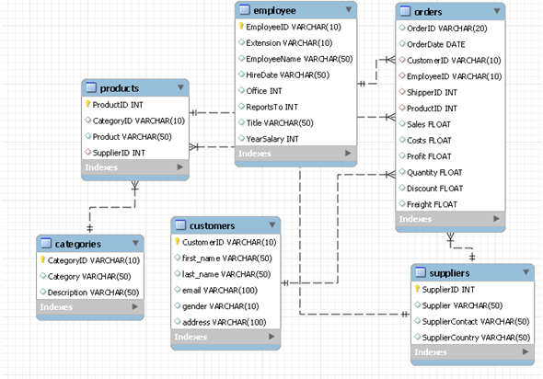

**Fig 2. Entity Relation Diagram.**

1. Dashboards:

8a. Dashboard1:

**Fig 3. Sales Dashboard.**

This dashboard provides an insightful overview of the sales trend for MAX Retail in the current year (2022) compared to the previous year (2021). The graphs in Fig 3 clearly demonstrates a remarkable growth in sales, indicating a 17.45% increase from the previous year. Additionally, the company has achieved a profit growth of 14.40% compared to 2021. Notably, there has been a substantial 107% increase in the total quantities sold, highlighting the strong performance of MAX Retail.

Analyzing the graph further, we observe that both years experienced relatively lower sales during the first two quarters, followed by a gradual increase in the subsequent six months. This trend suggests a consistent pattern of sales improvement throughout the year.

In terms of product categories, Women's Clothing emerges as the highest-selling category. Furthermore, the specific item "MinkkiPaxisii" stands out as the most popular product within the MAX Retail inventory.

Overall, this dashboard offers valuable insights into the sales performance of MAX Retail, showcasing positive growth, category dominance, and popular product preferences. These findings serve as valuable indicators for strategic decision-making and business optimization.

8b Dashboard2:

The provided dashboard in Fig 4 presents valuable insights regarding the company's sales, quantities sold, and profits for the current year. These insights play a crucial role in facilitating efficient inventory planning and sales management for the company.

From the analysis, it can be inferred that in 2022, there is a positive sales trend observed from April to December, with a slight dip in September and November. During these months, the average profit has shown an upward trend, indicating successful revenue generation.

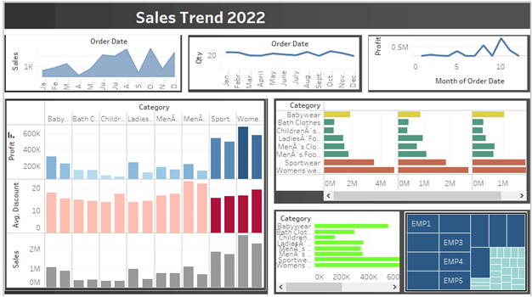

**Fig 4. Sales Trend 2022.**

Additionally, the graph reveals a linear relationship between the overall total sales and the overall sales trend. This suggests a consistent growth pattern in sales performance throughout the year.

These findings provide the company with important information for making informed decisions and optimizing their business strategies. By leveraging these insights, the company can enhance their inventory management, capitalize on sales opportunities, and drive profitability.

8cDashboard3:

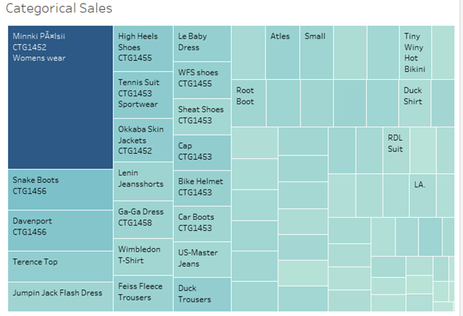

**Fig 5. Categorical Sales.**

The presented dashboard in Fig 5 highlights the top-selling items in both 2021 and 2022. The analysis indicates that Minkii Paalsii was the most sought-after item in the women's section, followed by Snake Boots and Davenport in the men's section. This valuable information will assist the company in effectively managing their supply chain operations to meet the demand for these popular products.

#### 8d Dashboard4:

The displayed dashboard in Fig 6. showcases the monthly sales data categorized by product type. A clear trend emerges, indicating that Sportswear and Women's wear consistently demonstrate high demand throughout the year. Particularly, the period from July to December stands out as the peak months for sales in these categories, with a significant number of units sold during this time.

**Fig 6. Monthly Category.**

#### 8e Dashboard5:

The presented dashboard in Fig 7 illustrates the periodic data of sales, profits, and quantities sold. It is evident that in both years, there is a noticeable trend of lower performance in the first two quarters, followed by a subsequent increase in the following months. This pattern indicates a consistent growth trajectory in sales, profits, and quantities sold as the year progresses.

**Fig 7.Periodic display of Sales Data(Quarterly).**

9.CRM IMPLEMENTATION– CRM is a tool that manages customer relations and maintains and tracks sales data. HubSpot is a free CRM portal which was used for storing sales data and managing customers and contacts. We tried a lot of CRM software CRM tools such as dynamics, salesforce, Monday but due to handy features and ease of use, we chose HubSpot as the CRM tool. Due to lack of features in the open-source version, We could not explore the tool and could not implement a lot of features.

9a Steps implemented in CRM -

1. **Registering company and creating company dashboard –** We kicked off the CRM implementation by registering company name and domain name and creating company dashboard in the HubSpot CRM.

**Fig 8.Company Dashboard in CRM.**

The dashboard in Fig 8 contains a lot of relevant information such as company name and logo, company address. A contact ribbon is placed at the top right which contains information of customes which with time can be used as contacts. Deals section contains the latest deals/ sales which are recently served. Tickets section contains ongoing ticket information raised by customers which are not served.

1. **Adding contact/ customer information in the CRM**. As we are using the open-sourcevariant of the CRM interface of CRM with SQL database was not possible. However, customer data was fed manually to the CRM. The same data was loaded in the DB as well. Customer data(Fig 9) along with the first name, last name, customer email, customer postal address was added to the CRM. Please find the figure below displaying the same.

**Fig 9 Customer Data in CRM.**

1. **Target Accounts/ Customers**- Target accounts(Fig 9) in CRM focuses to target high potential customers and contains some information about repeat customers. In our case out of 96 customers 22 were the target accounts identified by the CRM.

**Fig 11.Target Customers.**

1. **Adding Sales Data**–Sales data(Fig 12) was imported manually through CSV file. Clear representation was possible in HubSpot CRM of Deals/Sales data. Data was bifurcated into closed and open sales. Sales which open or closed were able to filter the data easily, which in turn helped Sales analytics. A total of 3,184 records were imported in CRM.

**FIG 12.Sales Data in CRM.**

1. **Sales Forecasting -**HubSpot offers sales forecasting(Fig 13) features which gives data of Sales count, amount earned by the organization in previous month. Dynamic sales tracking is visualized perfectly on the portal.

You can set goals for current and upcoming months which help setting targets of the organization. The data is set as a goal for the month of May 2023.

**Fig 13. Sales Forecasting in CRM.**

1. **Create team** – We can create team of 100 employees minimum in the paid version whereas the open source version can have a team of only one employee.

10. BI Process Workflow–

**Fig 14. BI Architecture**

Similar type process workflow(Fig 14) was followed by the BI team for business analysis for our Organization MaxRetail.

11.Conclusion -In conclusion, as business analysts entrusted by MAX Retail, our role is to evaluate and optimize their business operations by leveraging data-driven insights and advanced analytics. Despite the challenges posed by the COVID-19 outbreak, MAX Retail has managed to thrive and provide exceptional shopping experiences to its customers. With the gradual subsiding of the pandemic's impact, MAX Retail has experienced a significant resurgence, prompting the company to seek our expertise in evaluating and optimizing their operations.

Our current focus is on analyzing the sales performance of MAX Retail for the years 2021 and 2022. Through a meticulous examination of sales data, customer behavior, and key metrics, we aim to uncover insights and patterns that can drive further growth and success for MAX Retail during these specific periods. While our analysis does not encompass the supply chain aspect, our dedication lies in optimizing their sales operations and identifying opportunities for improvement based on the available sales data.

Solutions

Based on the insights gained from the analysis, MAX Retail should focus on further capitalizing on the growth in sales and profits. This can be achieved by increasing inventory levels and ensuring the availability of popular products, especially in the women's section.

MAX Retail should consider implementing targeted marketing strategies for the popular products identified, such as "MinkkiPaxisii," Snake Boots, and Davenport. This will help maximize sales opportunities and increase customer engagement.

The company should also prioritize inventory management to meet the demand for top-selling items. By optimizing their supply chain operations, they can minimize stockouts and enhance customer satisfaction.

MAX Retail should continue to monitor sales trends and customer preferences using the chosen business intelligence and analytics platform, Tableau. This will enable them to adapt their strategies and offerings, accordingly, ensuring continued growth and success.

Leveraging the HubSpot CRM tool can further enhance customer relationship management and provide a personalized experience. MAX Retail should utilize the CRM features to engage with customers, analyze their preferences, and provide tailored recommendations.

By implementing these solutions and leveraging data-driven insights, MAX Retail can optimize their sales operations, enhance customer satisfaction, and drive further growth and success.

References –

[1] <https://www.tableau.com/en-gb/trial/data-mapping-tool?utm_campaign_id=2017049&utm_campaign=Prospecting-CHRTMPGR-ALL-ALL-ALL-ALL&utm_medium=Paid+Search&utm_source=Google+Search&utm_language=EN&utm_country=UKI&kw=tableau%20map%20data&adgroup=CTX-Mapping-Data-E&adused=RSA&matchtype=b&placement=&d=7013y000000vYhH&nc=7013y0000029zDoAAI&cq_cmp=18949423357&cq_net=g&cq_plac=&gad=1&gclid=Cj0KCQjwsIejBhDOARIsANYqkD3IUEJb-aVUkyzrrHrx8HyYLlfe4ucKvFBZG-dcl-Ua-TAjuLqPNiMaAnN8EALw_wcB&gclsrc=aw.ds>

[2] <https://www.hubspot.com/products/get-started-f049?utm_id=607212716859&utm_medium=paid&utm_source=google&utm_term=marketing_hubspot_EN&utm_campaign=Marketing_MQLs_EN_EMEA_UKI_Brand-HubSpot_e_c_campaignid856706782_agid45114446858_google&utm_content=&hsa_ver=3&hsa_net=adwords&hsa_acc=2734776884&hsa_kw=hubspot&hsa_grp=45114446858&hsa_mt=e&hsa_cam=856706782&hsa_ad=607212716859&hsa_tgt=kwd-298569398281&hsa_src=g&gad=1&gclid=Cj0KCQjwsIejBhDOARIsANYqkD0CpwYCQ_z-ycVf07WBTy1aZdsEe1VD0logNIjGc7K9ugtbrA9YEuAaAg1TEALw_wcB>

[3]https://www.techtarget.com/searchcio/definition/balanced-scorecard-methodology#:~:text=The%20balanced%20scorecard%20is%20a,organization's%20strategic%20goals%20are%20met.

Video Link:

<https://youtu.be/3Fqy0Xh3aFA>